1.What is Monitoring & Observability? Explain in your own words.

Monitoring:
In my own words, monitoring is like setting up a security camera for your systems and applications — you keep an eye on metrics such as CPU usage, memory, disk space, response times, errors, etc., so you can detect if something is going wrong. It’s mostly about collecting and displaying metrics to know the current and past state of your systems.
Observability:
Observability goes a step further — instead of just showing you “what” is wrong, it gives you enough data to figure out “why” it’s happening. It combines metrics, logs, and traces so you can debug issues, even those you didn’t plan for. Observability is about gaining deep visibility into the internal state of the system by using the outputs it produces.
Key Difference:
Monitoring = “Something is wrong”
Observability = “Here’s why it’s wrong”

2.List down various Monitoring Tools available in the market.
Infrastructure & Application Monitoring Tools:
- Prometheus – Open-source, time-series database for metrics, very popular in Kubernetes monitoring.
- Grafana – Visualization tool that works with Prometheus and other data sources to build dashboards.
- Nagios – Long-standing monitoring tool for servers, networks, and applications.
- Zabbix – Enterprise-grade open-source monitoring for networks, servers, and cloud.
- Datadog – SaaS-based monitoring for infrastructure, APM, logs, and security.
- New Relic – Full-stack observability with metrics, traces, and logs.
- Splunk – Mainly for log management but also used for observability.
- Elastic Stack (ELK) – Elasticsearch, Logstash, Kibana; used for log analytics and observability.
- VictoriaMetrics – Scalable alternative to Prometheus for large-scale setups.
- Sysdig – Container security and monitoring platform.
3.Setup Prometheus on an EC2 instance
# ====== SYSTEM UPDATE ======
sudo dnf update -y

# ====== CREATE PROMETHEUS USER & FOLDERS ======
sudo useradd --no-create-home --shell /bin/false prometheus
sudo mkdir /etc/prometheus /var/lib/prometheus
sudo chown prometheus:prometheus /etc/prometheus /var/lib/prometheus

# ====== INSTALL PROMETHEUS ======
wget https://github.com/prometheus/prometheus/releases/download/v2.52.0/prometheus-2.52.0.linux-amd64.tar.gz
tar -xvf prometheus-2.52.0.linux-amd64.tar.gz
sudo mv prometheus-2.52.0.linux-amd64/prometheus /usr/local/bin/
sudo mv prometheus-2.52.0.linux-amd64/promtool /usr/local/bin/
sudo mv prometheus-2.52.0.linux-amd64/consoles /etc/prometheus
sudo mv prometheus-2.52.0.linux-amd64/console_libraries /etc/prometheus
sudo chown -R prometheus:prometheus /etc/prometheus/consoles /etc/prometheus/console_libraries

# ====== INSTALL NODE EXPORTER ======
wget https://github.com/prometheus/node_exporter/releases/download/v1.7.0/node_exporter-1.7.0.linux-amd64.tar.gz
tar -xvf node_exporter-1.7.0.linux-amd64.tar.gz
sudo mv node_exporter-1.7.0.linux-amd64/node_exporter /usr/local/bin/
sudo chown prometheus:prometheus /usr/local/bin/node_exporter

# ====== PROMETHEUS CONFIGURATION ======
sudo tee /etc/prometheus/prometheus.yml > /dev/null <<EOF
global:
scrape_interval: 15s

scrape_configs:
- job_name: 'prometheus'
static_configs:
- targets: ['localhost:9090']

- job_name: 'node'
static_configs:
- targets: ['localhost:9100']
EOF
sudo chown prometheus:prometheus /etc/prometheus/prometheus.yml

# ====== CREATE SYSTEMD SERVICE FOR PROMETHEUS ======
sudo tee /etc/systemd/system/prometheus.service > /dev/null <<EOF
[Unit]
Description=Prometheus
Wants=network-online.target
After=network-online.target

[Service]
User=prometheus
ExecStart=/usr/local/bin/prometheus \\
--config.file=/etc/prometheus/prometheus.yml \\
--storage.tsdb.path=/var/lib/prometheus/
Restart=always

[Install]
WantedBy=multi-user.target
EOF

# ====== CREATE SYSTEMD SERVICE FOR NODE EXPORTER ======
sudo tee /etc/systemd/system/node_exporter.service > /dev/null <<EOF
[Unit]
Description=Node Exporter
After=network.target

[Service]
User=prometheus
ExecStart=/usr/local/bin/node_exporter
Restart=always

[Install]
WantedBy=multi-user.target
EOF

# ====== START & ENABLE SERVICES ======
sudo systemctl daemon-reload
sudo systemctl enable prometheus
sudo systemctl enable node_exporter
sudo systemctl start prometheus
sudo systemctl start node_exporter

# ====== OUTPUT INFO ======
echo "Prometheus running at: http://<EC2-Public-IP>:9090"
echo "Node Exporter metrics: http://<EC2-Public-IP>:9100/metrics"
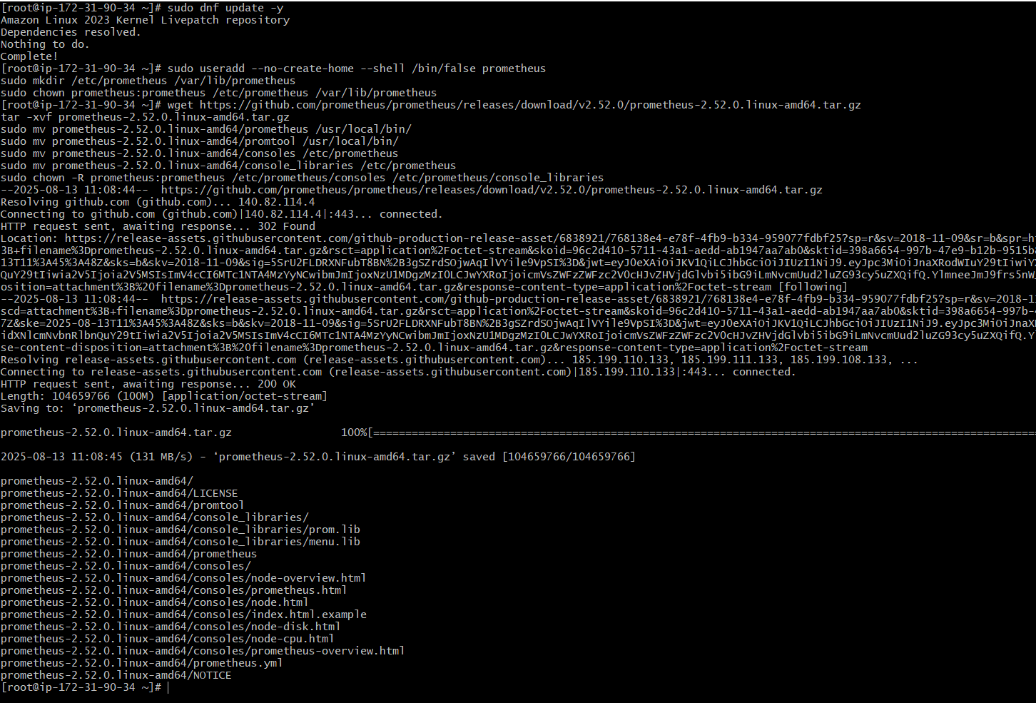
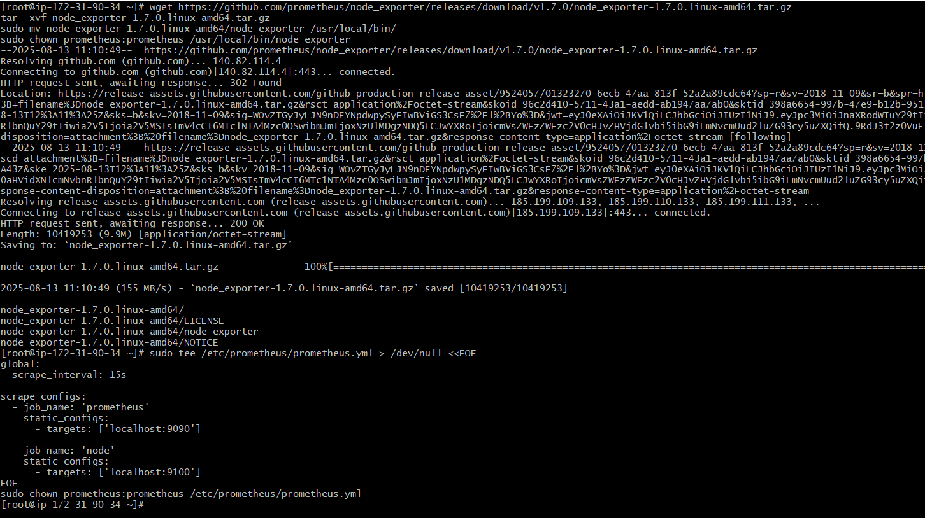

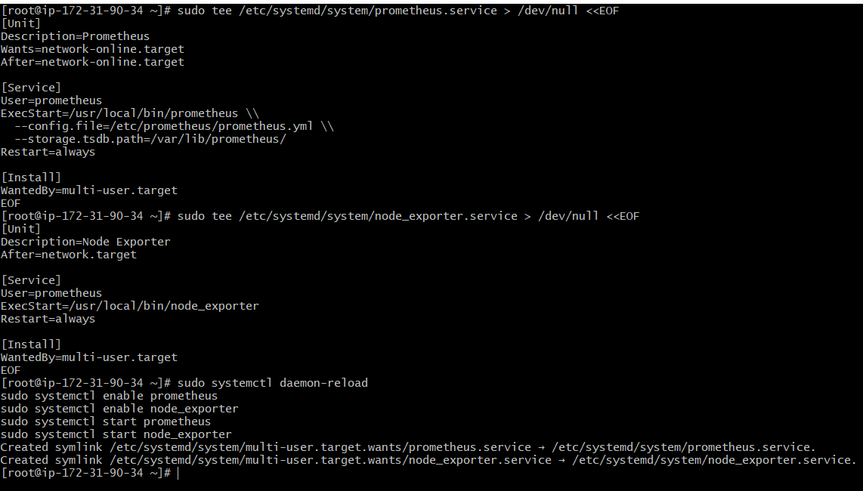
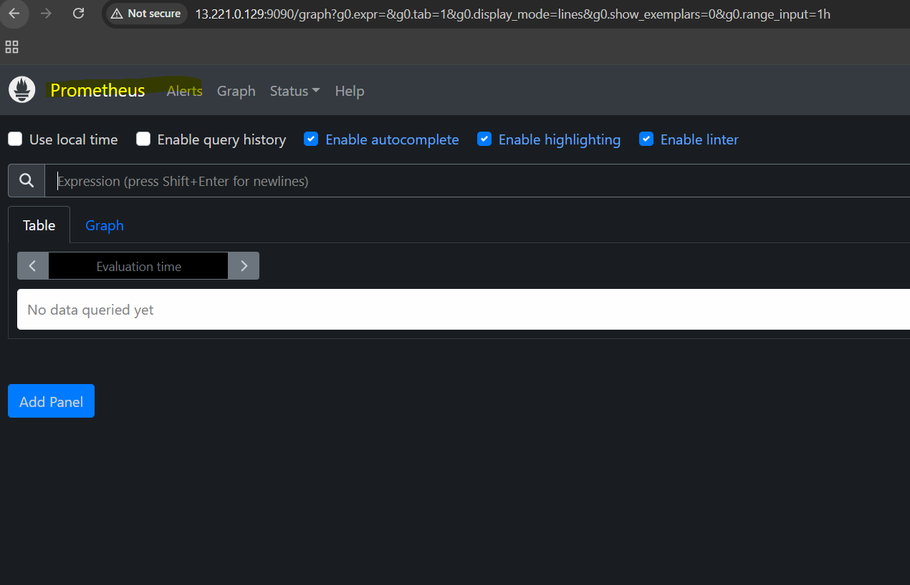
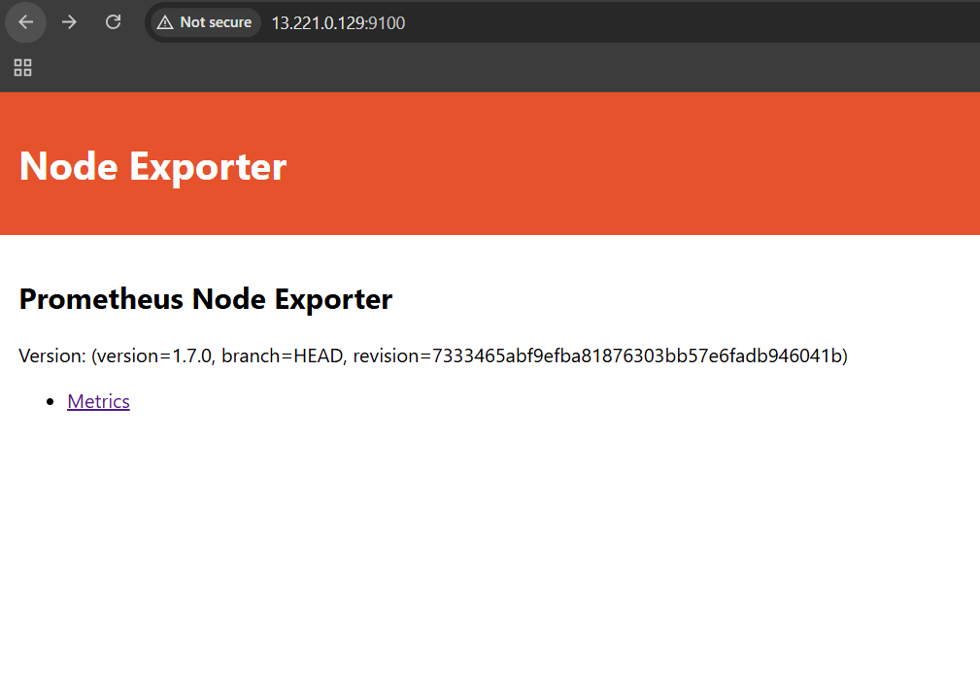
4.Setup Grafana on an EC2 instance
# ====== DOWNLOAD AND INSTALL GRAFANA ======
wget https://dl.grafana.com/enterprise/release/grafana-enterprise-10.4.1-1.x86_64.rpm
sudo dnf install -y grafana-enterprise-10.4.1-1.x86_64.rpm

# ====== ENABLE AND START GRAFANA SERVICE ======
sudo systemctl enable grafana-server
sudo systemctl start grafana-server

# ====== CHECK SERVICE STATUS ======
sudo systemctl status grafana-server
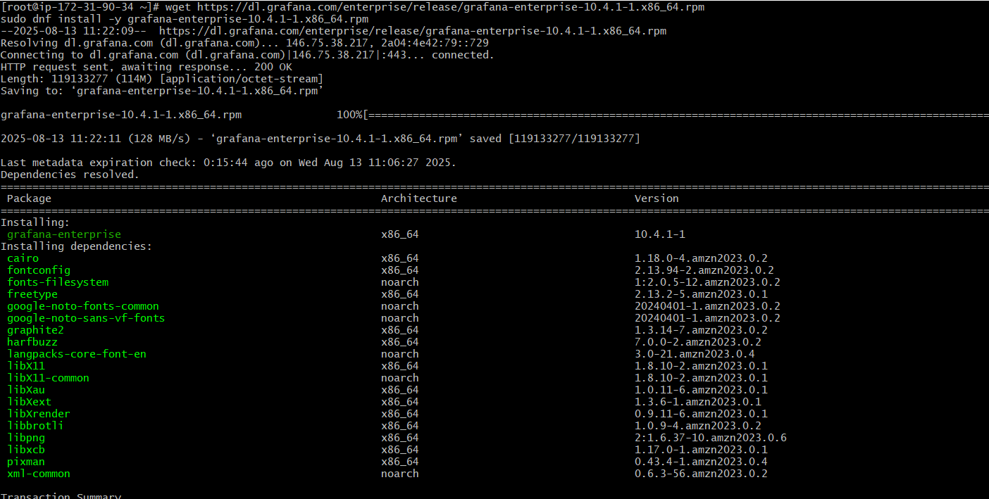
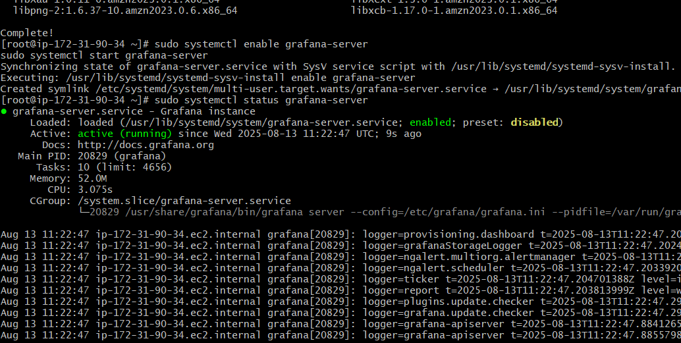
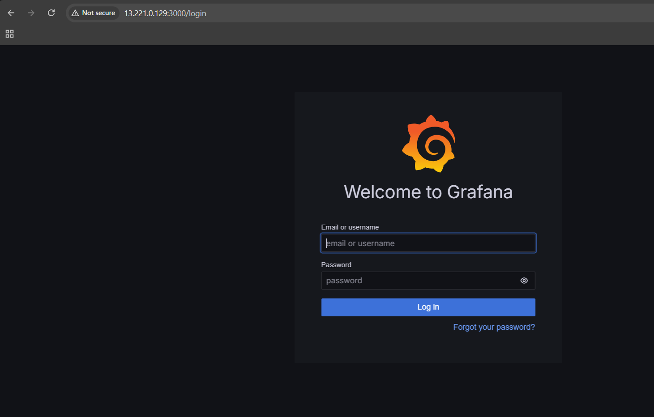
5.Understand the Prometheus Architecture and explain each component with its role

Prometheus architecture consists of several core components that work together to collect, store, and query metrics data for monitoring and alerting. Here's an explanation of each component with its role:

Prometheus Server
Role: The main component responsible for scraping and storing time series data.
Function: It periodically collects metrics from configured targets via HTTP endpoints (called exporters), stores scraped metrics locally in a time-series database, and handles querying and alerting.
Storage: Stores data in a custom, highly efficient format on local disk.

Exporters
Role: Exporters are components or agents that expose metrics data in a format Prometheus can scrape.
Function: Exporters run alongside the monitored system (or application) and provide metrics via a HTTP endpoint. Examples:
Node Exporter: Exposes host machine metrics like CPU, memory, disk usage.
Blackbox Exporter: Monitors endpoints for availability and latency.
Application-specific exporters: Custom exporters for JVM, databases, etc.
Exporters translate application/domain-specific metrics to the Prometheus exposition format.

Service Discovery
Role: Dynamic identification of targets to scrape metrics from.
Function: Automatically finds instances (pods, VMs, services) in cloud environments or orchestration platforms like Kubernetes without manual configuration. This keeps Prometheus scraping updated targets as infrastructure changes.

PromQL (Prometheus Query Language)
Role: Powerful querying language used for extracting and aggregating metrics data.
Function: Enables users to write queries that aggregate, filter, and correlate metrics stored in the time-series database for analysis, dashboarding, and alerting.

Alertmanager
Role: Manages alerts generated by Prometheus rules.
Function: Receives alert notifications from Prometheus, deduplicates, groups, and routes them to notification channels such as email, Slack, PagerDuty, etc. It supports silencing and inhibition of alerts.

Pushgateway
Role: Supports metrics for short-lived or batch jobs.
Function: Allows ephemeral jobs to push metrics to Prometheus asynchronously. Useful when jobs do not expose metrics endpoints directly.

Web UI / Dashboards
Role: User interface for querying and visualizing metrics.
Function: Prometheus provides a basic built-in web UI to execute PromQL queries and visualize results. Grafana is commonly used as a more advanced dashboarding and visualization tool integrated with Prometheus.

Summary Table
Component | Role | Function
Prometheus Server | Core metrics collection & storage | Scrapes targets, stores time series data, runs queries
Exporters | Metrics exposure | Provide metrics HTTP endpoints for Prometheus to scrape
Service Discovery | Target identification | Automatically finds targets in dynamic environments
PromQL | Query language | Enables advanced querying and aggregation of metrics
Alertmanager | Alert handling | Processes and routes alerts to notification systems
Pushgateway | Push model support | Receives ephemeral job metrics asynchronously
Web UI/Dashboards | Visualization | Querying and visual metrics display interface

These components together make Prometheus a robust monitoring and alerting system suitable for dynamic cloud-native environments.
6.Use Prometheus to monitor EC2 Metrics like CPU, Memory, and Uptime

- Node Exporter runs on your EC2 instance and exposes system metrics (CPU, memory, uptime, disk, etc.) on port 9100.

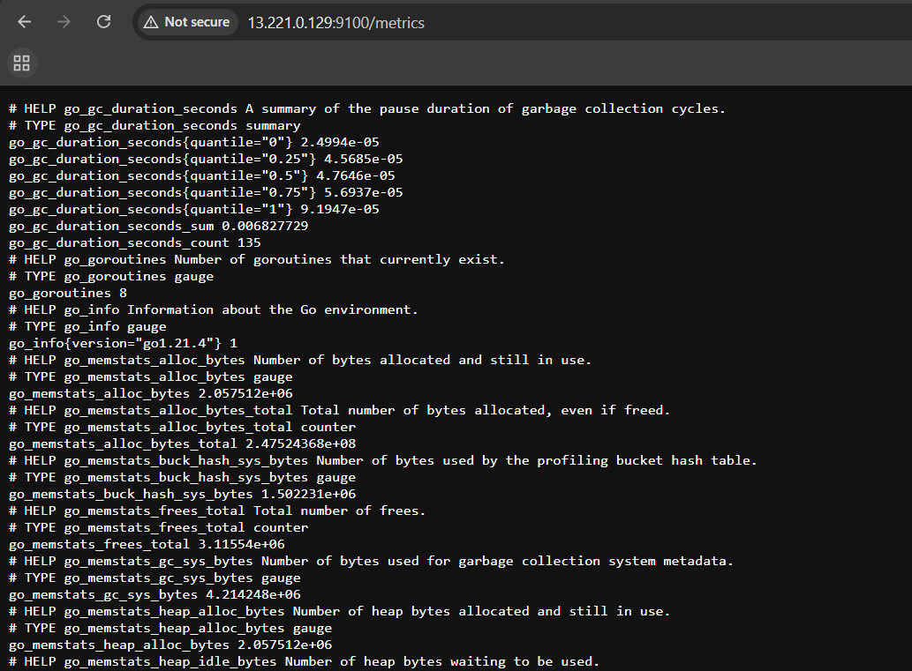

- Prometheus configuration file /etc/prometheus/prometheus.yml includes scraping these metrics by adding a scrape job pointing to Node Exporter:

scrape_configs:
- job_name: 'prometheus' # Prometheus scrapes itself on port 9090
static_configs:
- targets: ['localhost:9090']

- job_name: 'node' # Node Exporter metrics scrape job
static_configs:
- targets: ['localhost:9100'] # Node Exporter runs locally exposing EC2 metrics
This section instructs Prometheus to periodically pull metrics from the local Node Exporter service, which provides detailed system metrics for your EC2 instance.

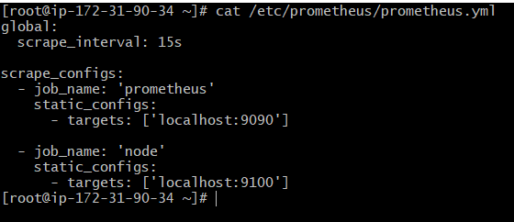

- Prometheus collects the raw metrics from Node Exporter, which include:
- node_cpu_seconds_total{mode="idle"} to measure CPU idle time
- node_memory_MemAvailable_bytes for available memory
- node_time_seconds - node_boot_time_seconds for system uptime

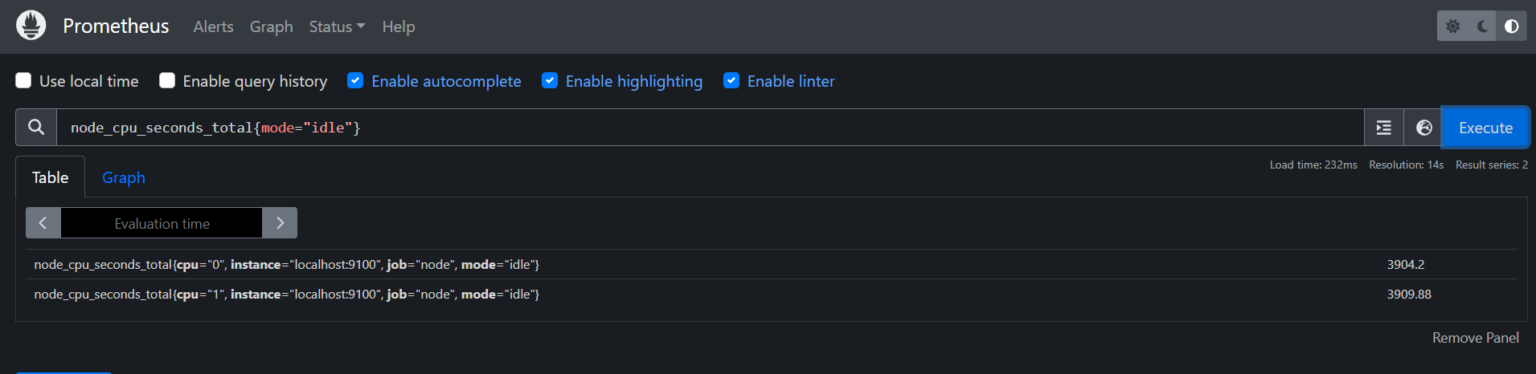
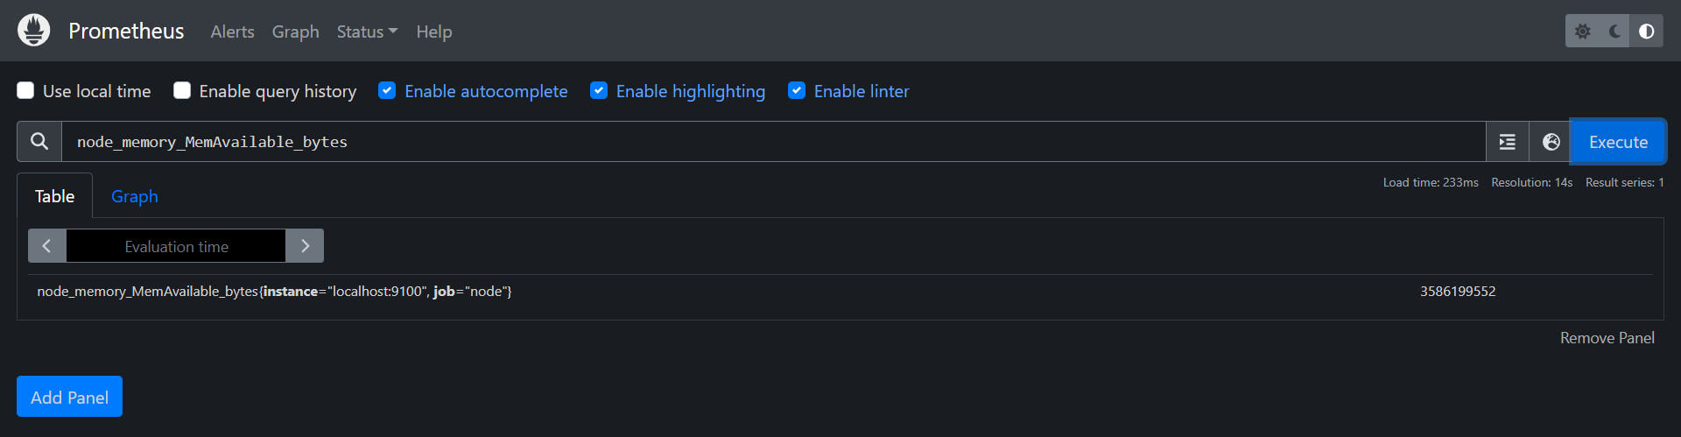
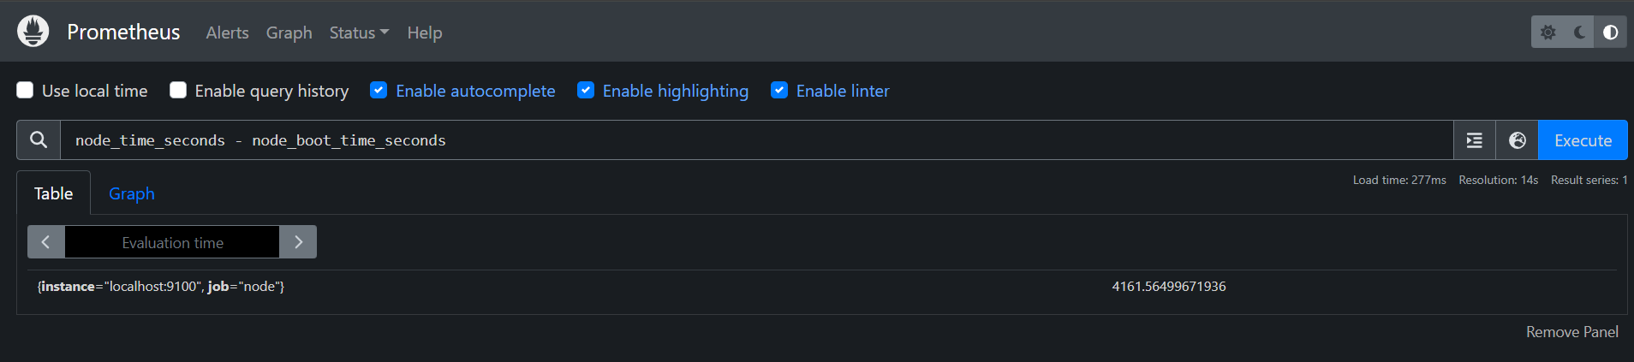

7.Create a Grafana Dashboard to visualize metrics from Step 6

# ====== 1. Now in browser steps ======
# - Go to http://<EC2-Public-IP>:3000
# - Login with admin / admin, change password
# - Click 'Gear icon (Configuration)' -> Data sources -> Add data source
# - Select 'Prometheus'
# - URL: http://localhost:9090
# - Save & Test

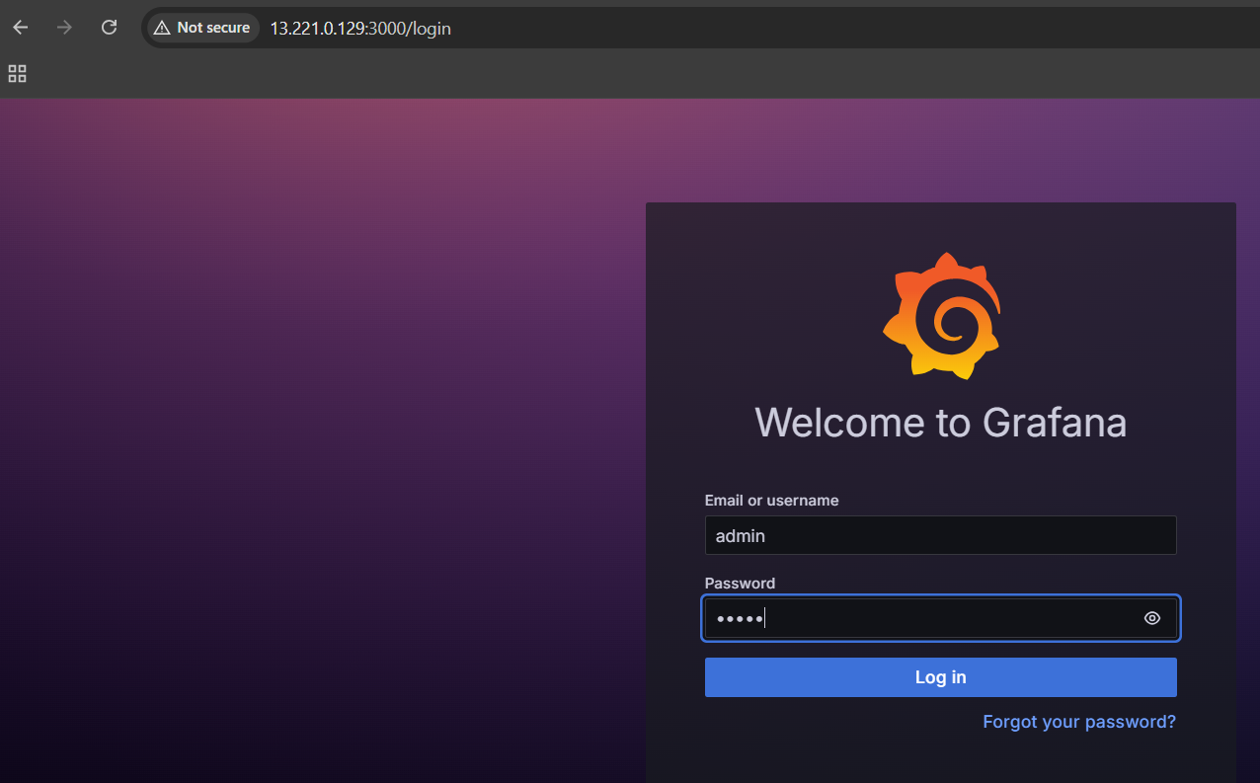
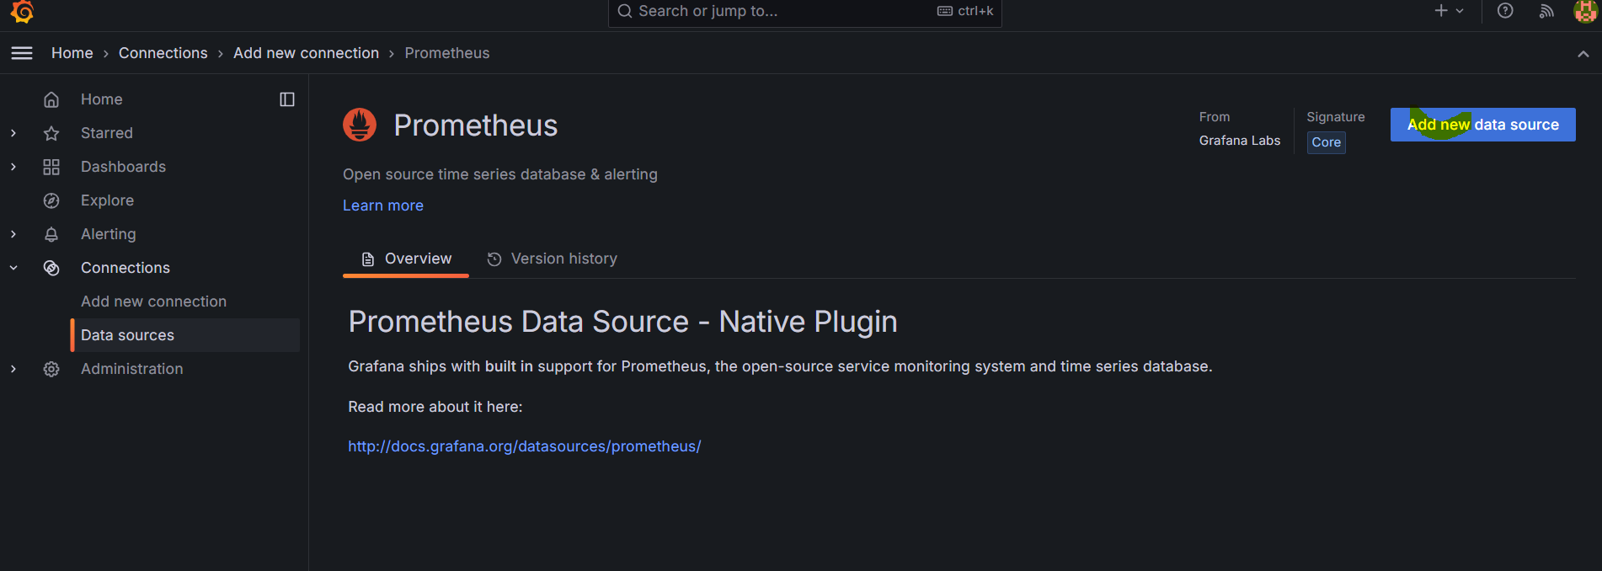
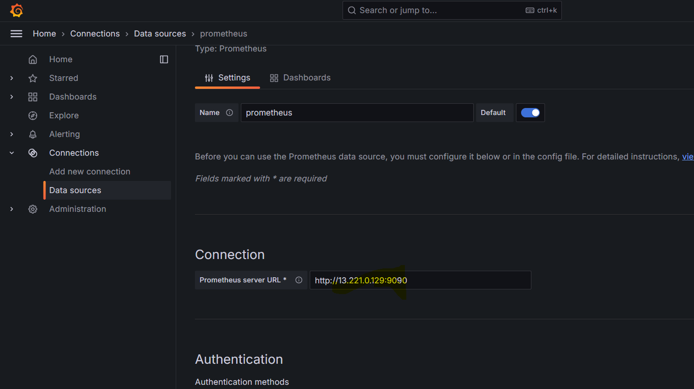
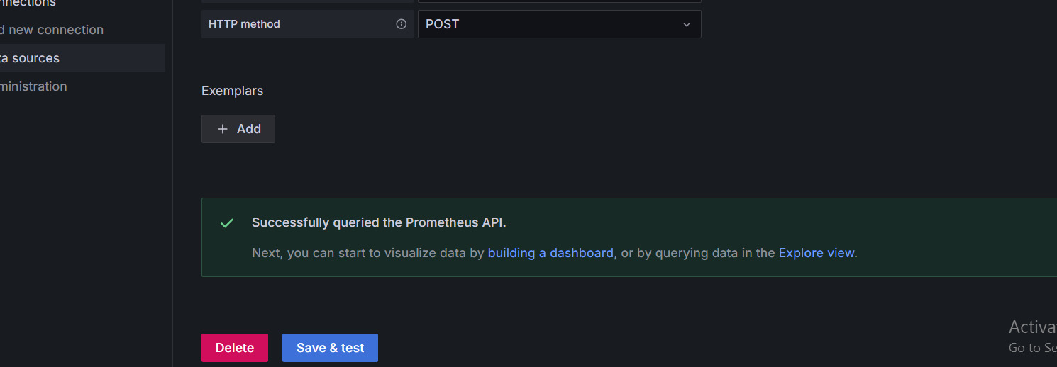

# ====== 2. Import dashboard ID 1860 ======
# - In Grafana UI, click "+" -> Import
# - Enter dashboard ID: 1860
# - Click "Load", choose Prometheus as data source, click "Import"
# - You will now see full Node Exporter metrics dashboard with CPU, Memory, Uptime, Disk, Network etc.

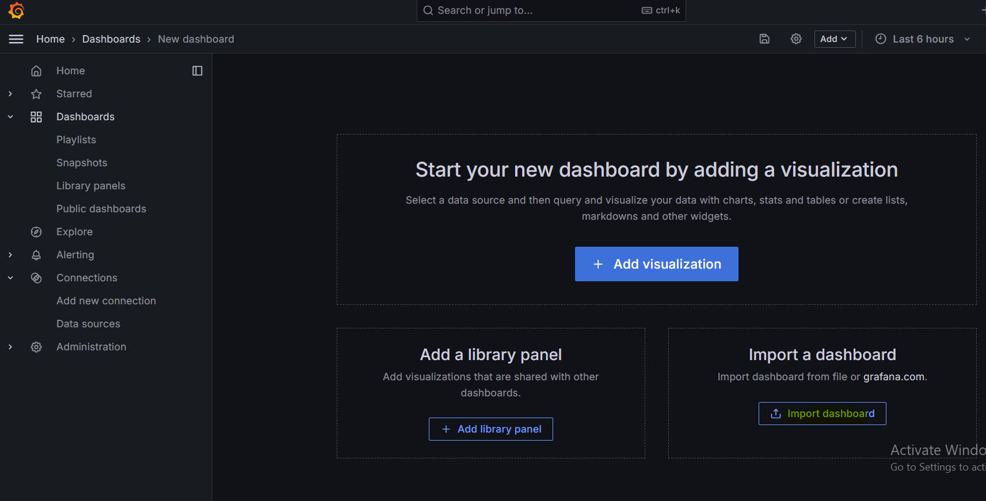
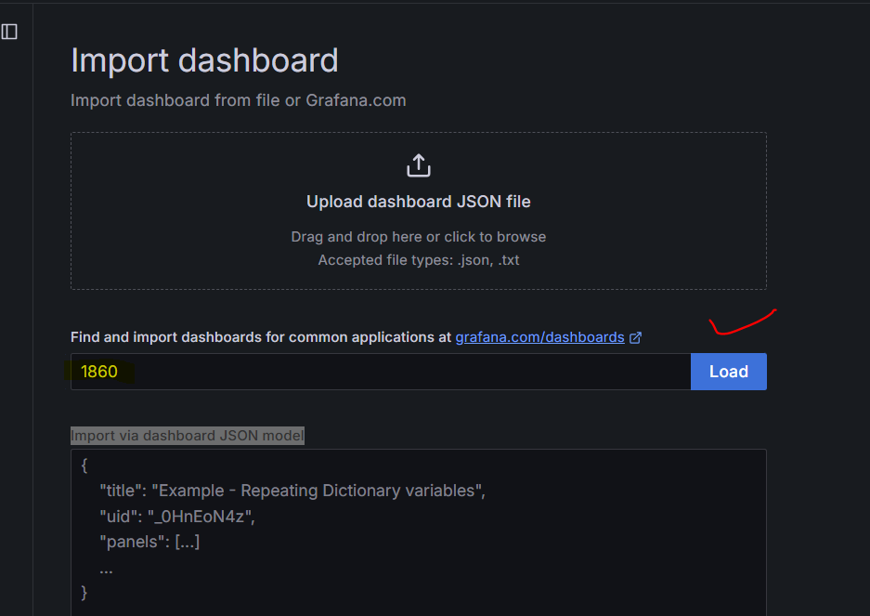
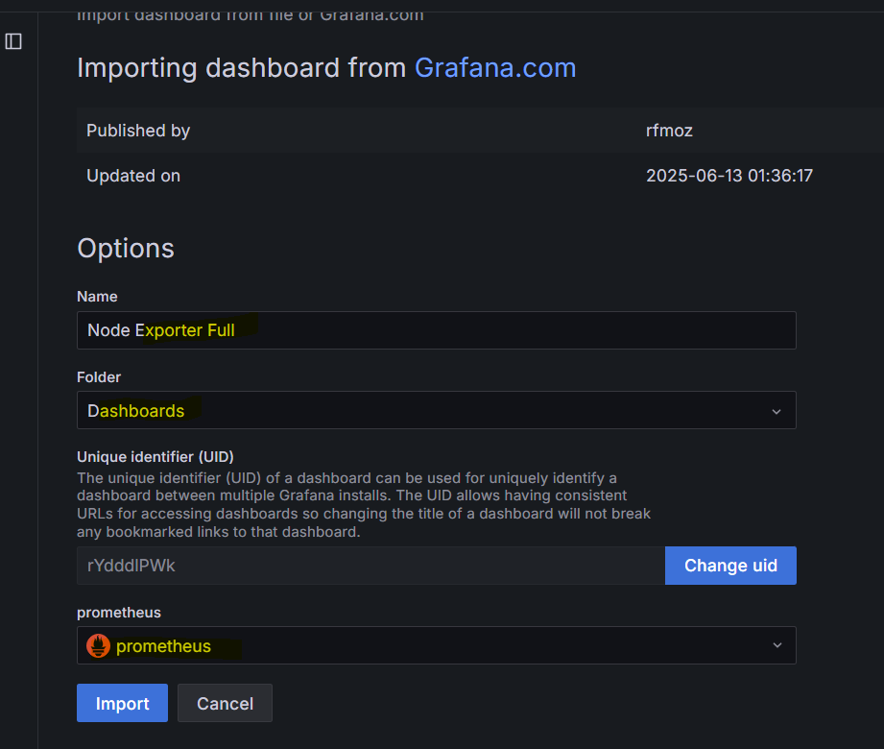
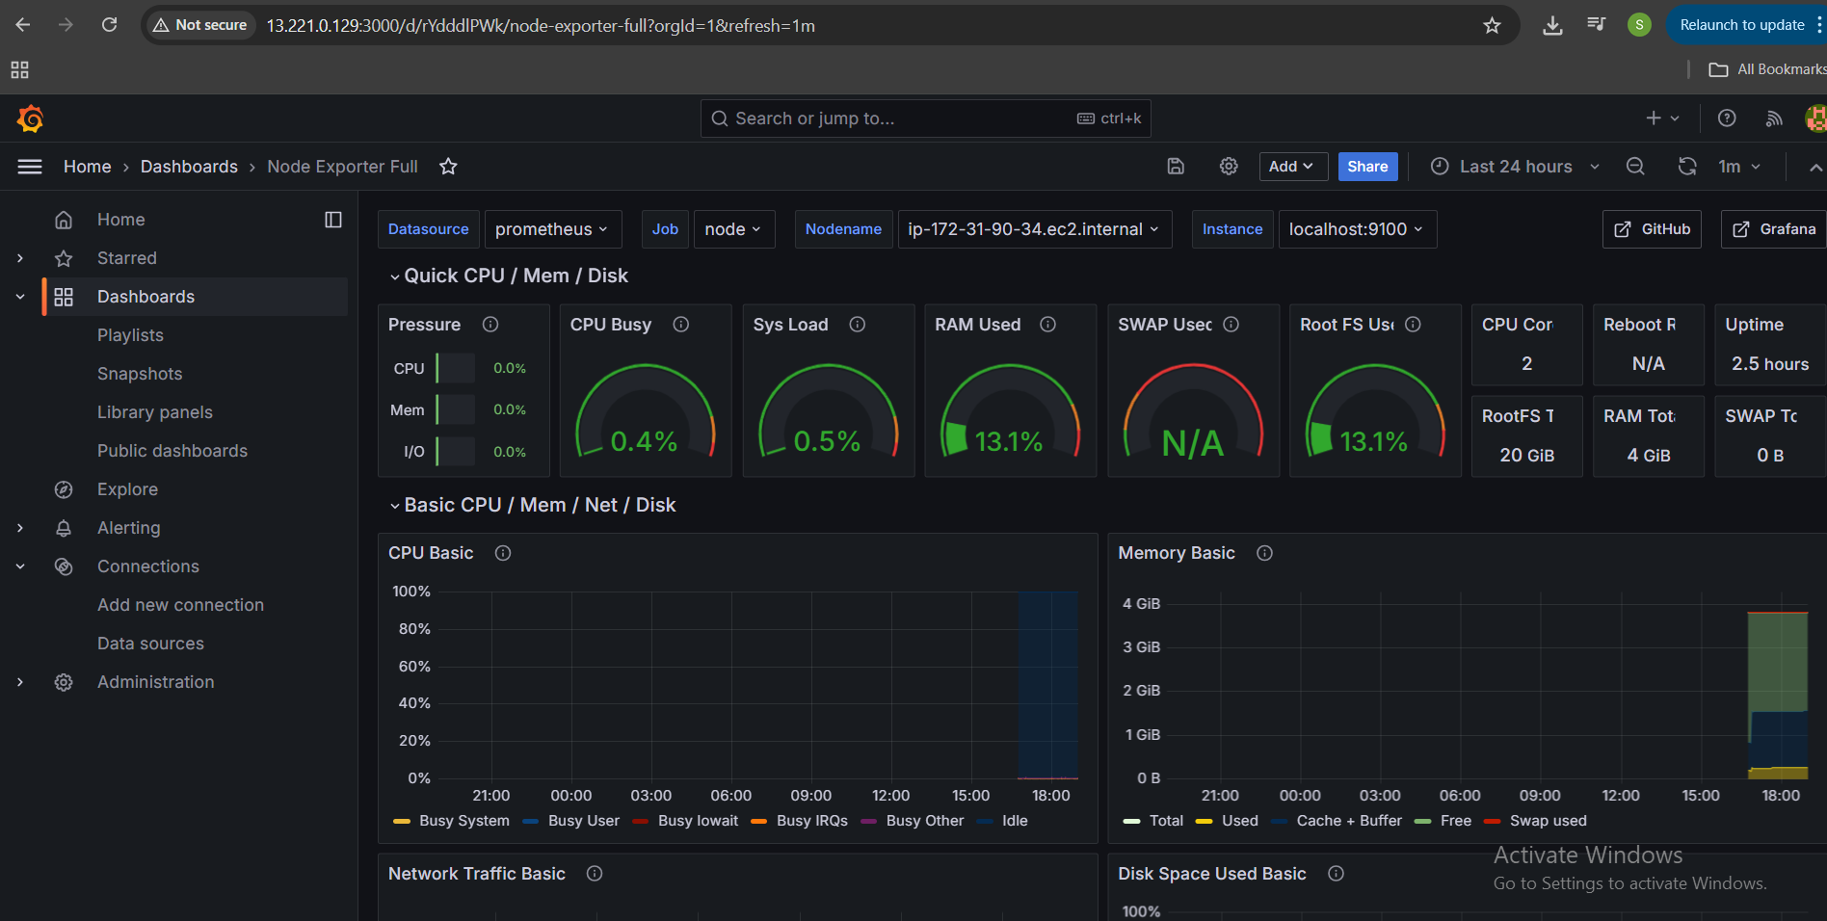
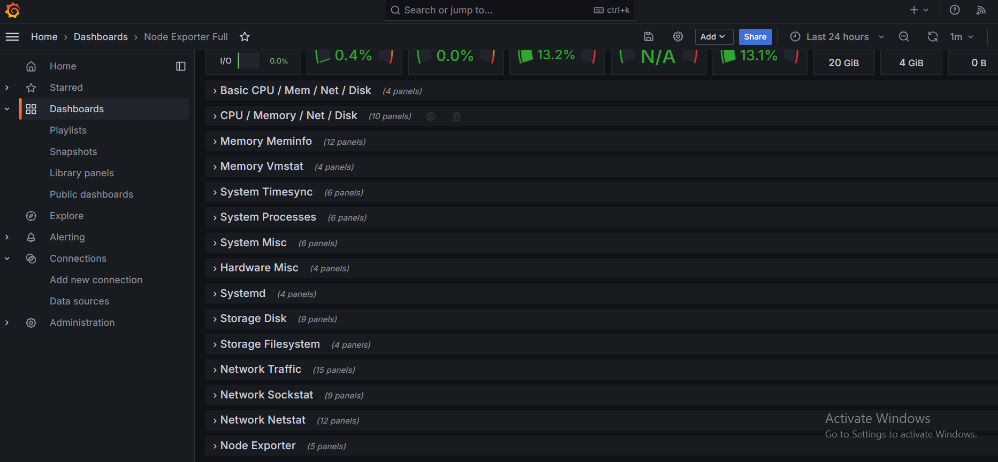

8.Configure Slack & Email Alerts if CPU goes below 50%

- Create Notification Channels

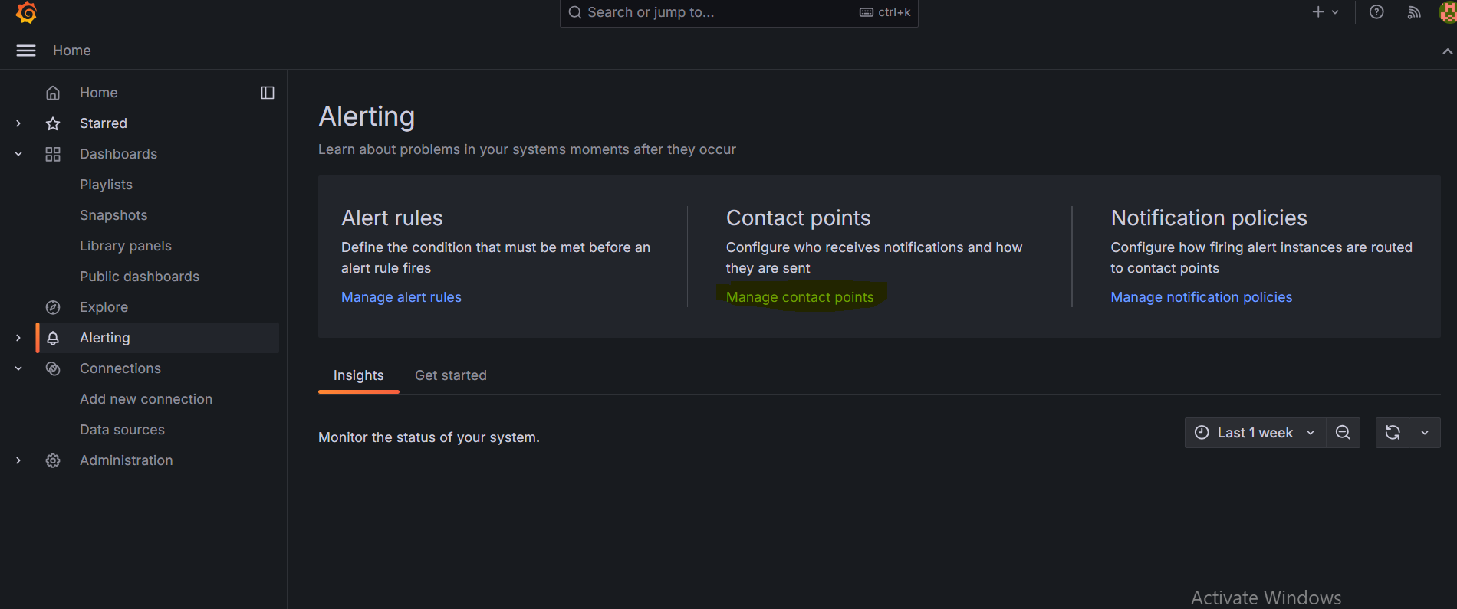

Slack
- Alerting → Contact points → + Add contact point
- Type: Slack
- Enter your Slack Webhook URL
- Save
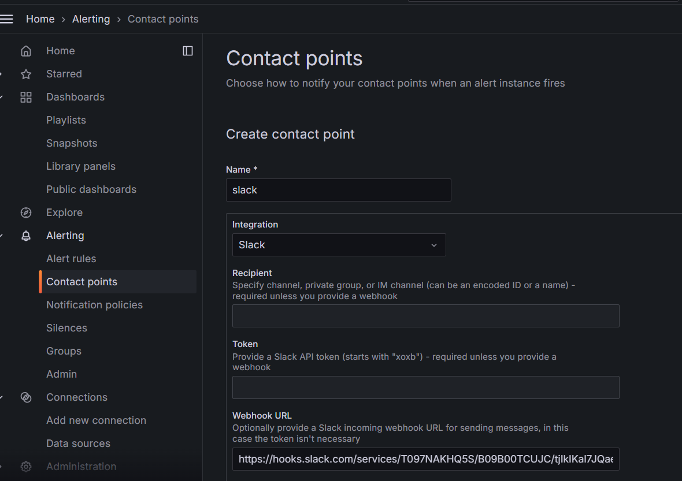

Email
- In grafana.ini configure SMTP (if not done)
- Alerting → Contact points → + Add contact point
- Type: Email
- Enter recipient email(s)
- Save
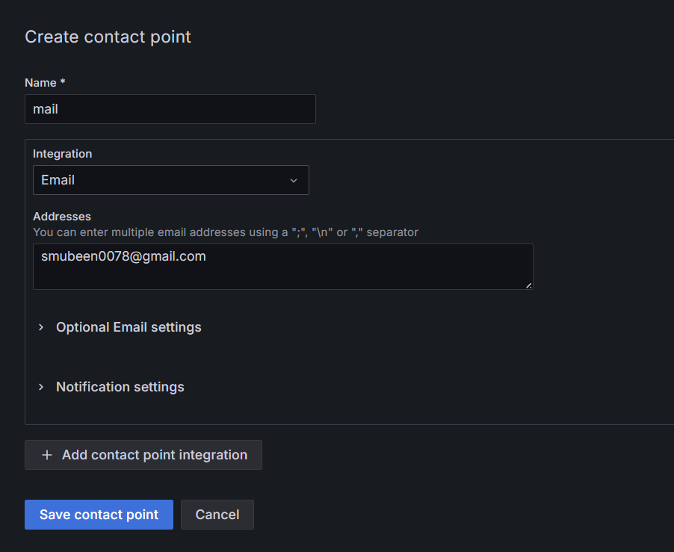

2. Create Alert Rule for CPU < 50%
- Go to your dashboard → Edit or create a panel
- Query:

100 - (avg by(instance) (rate(node_cpu_seconds_total{mode="idle"}[5m])) * 100)
- In Alert tab: Condition = < 50
- Assign both Slack and Email contact points
- Save
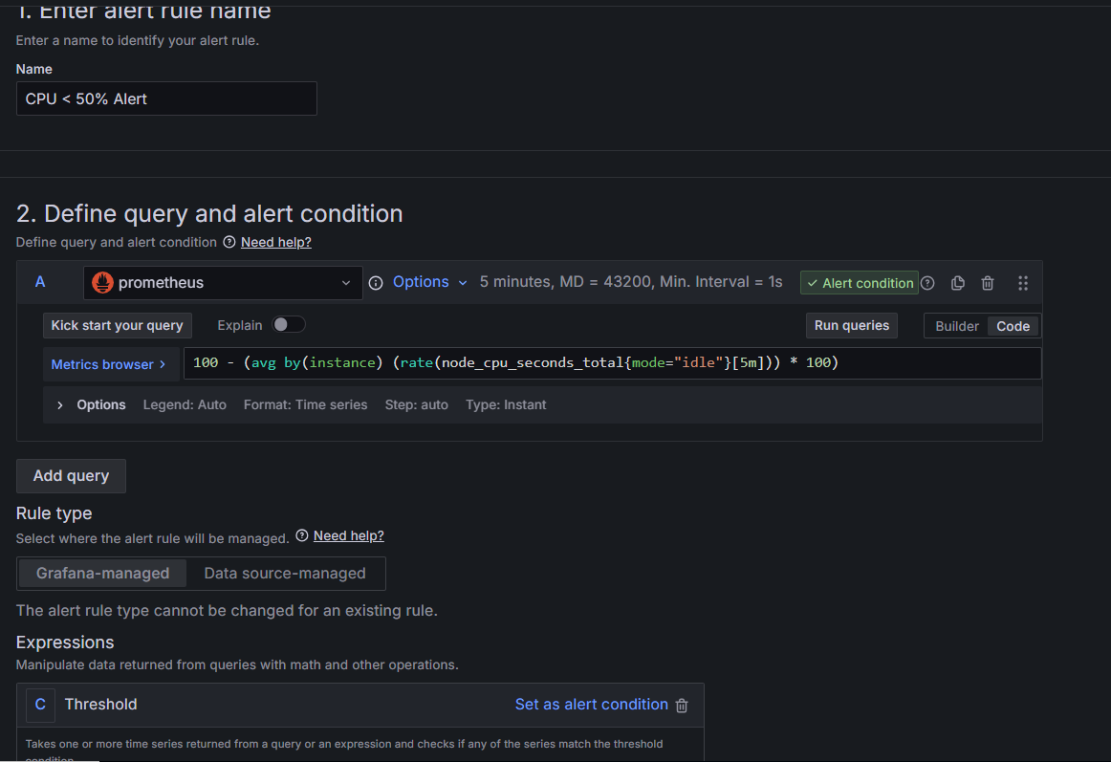
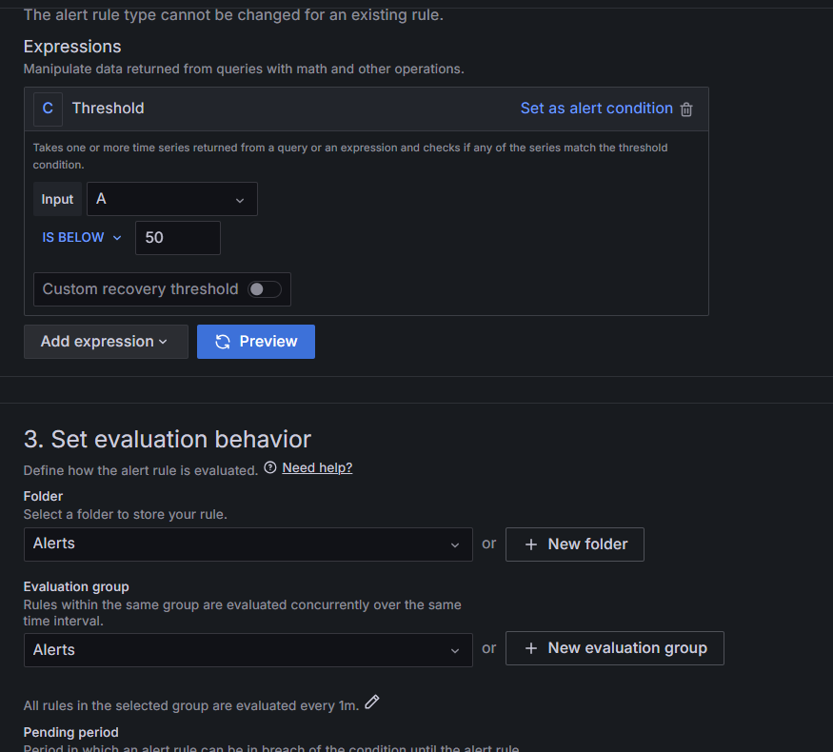
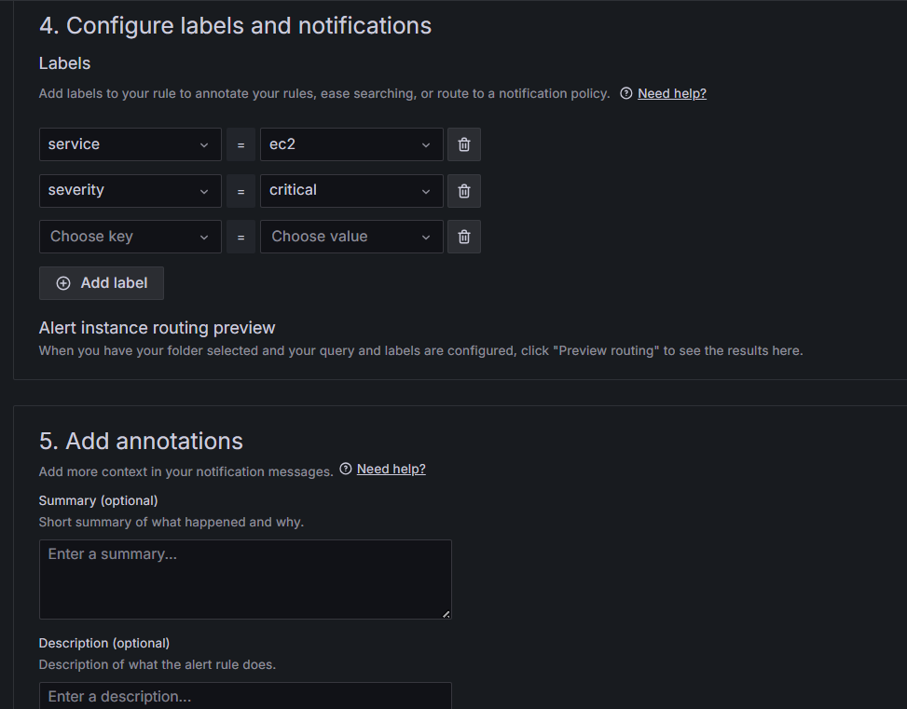
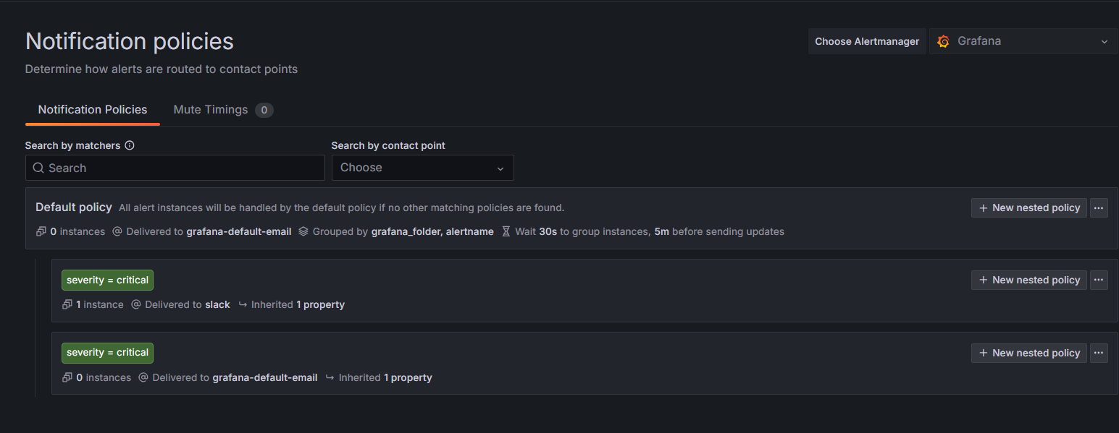
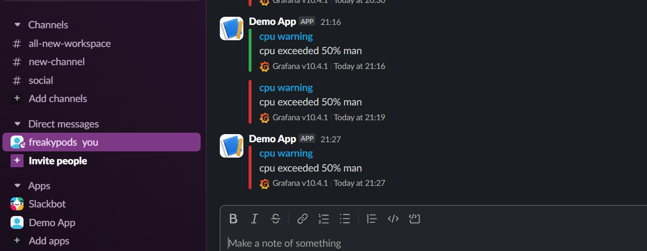

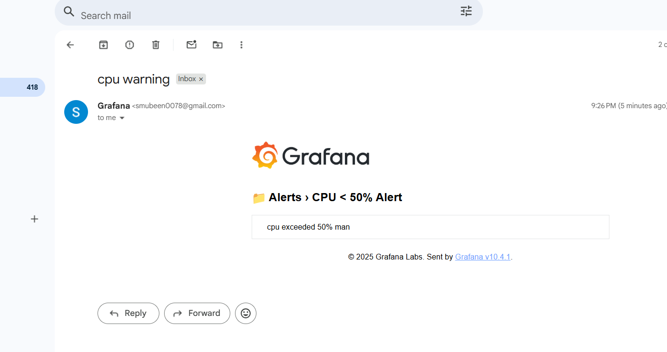
9.Deploy Prometheus & Grafana on EKS Cluster
Need to install helm cli to execute the task.
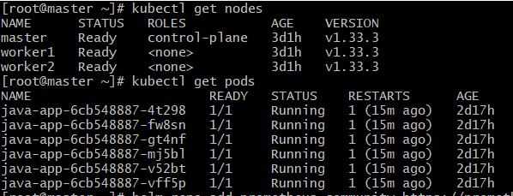

# --- FRESH INSTALL ---
helm repo add prometheus-community https://prometheus-community.github.io/helm-charts
helm repo update
kubectl create namespace monitoring
helm install prometheus prometheus-community/kube-prometheus-stack --namespace monitoring

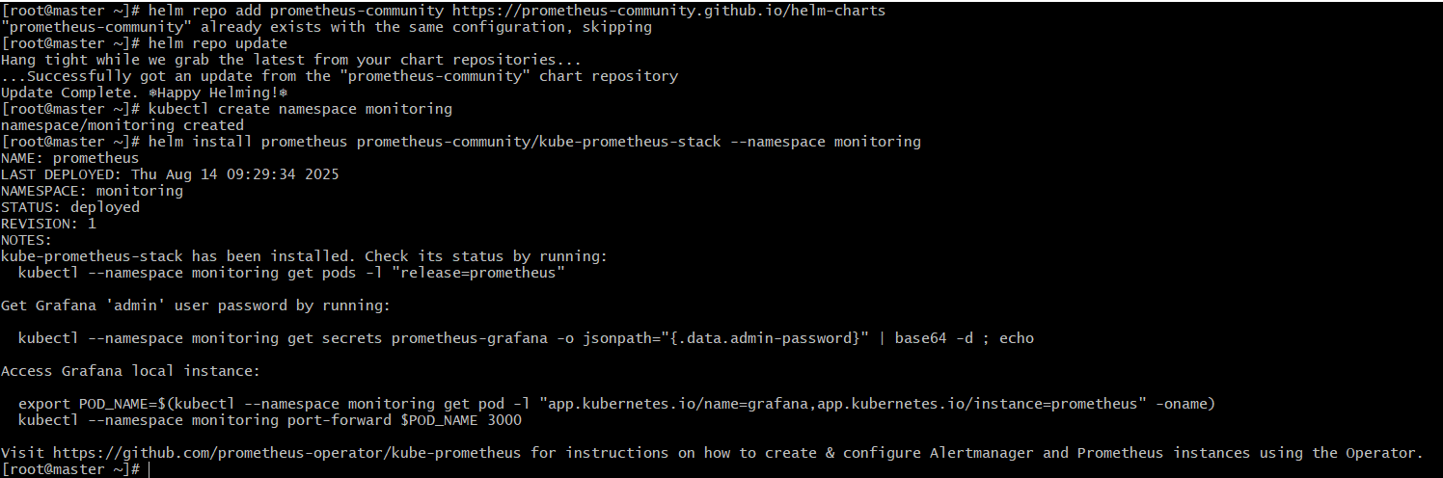

# --- CHECK DEPLOYMENT ---
kubectl get pods -n monitoring

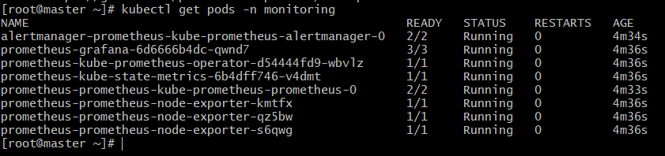

# --- EXPOSE SERVICES VIA NODEPORT ---
kubectl expose service prometheus-kube-prometheus-prometheus --type=NodePort --target-port=9090 --name=prometheus-nodeport -n monitoring
kubectl expose service prometheus-grafana --type=NodePort --target-port=3000 --name=grafana-nodeport -n monitoring
kubectl get svc -n monitoring

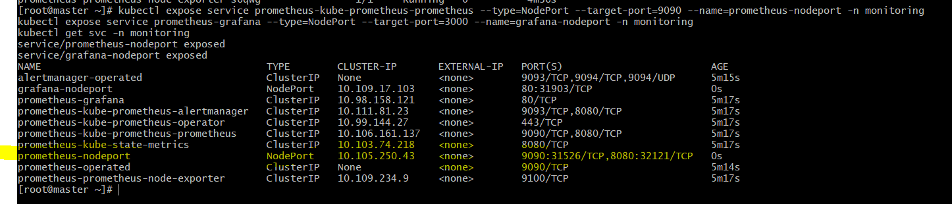

# --- GET NODE IP TO ACCESS ---
kubectl get nodes -o wide

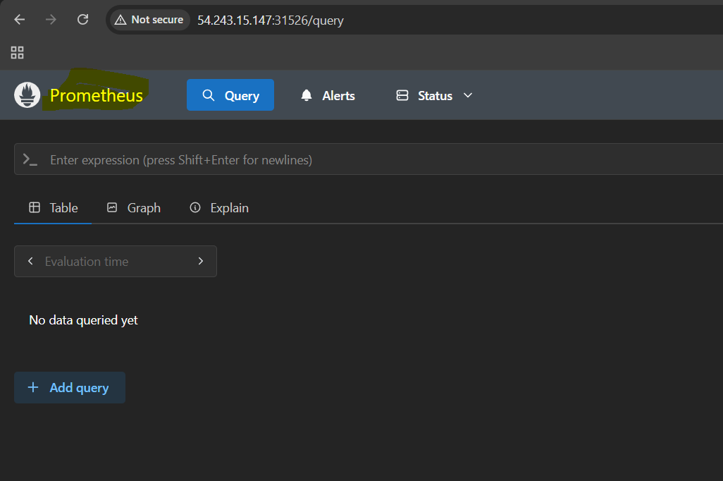

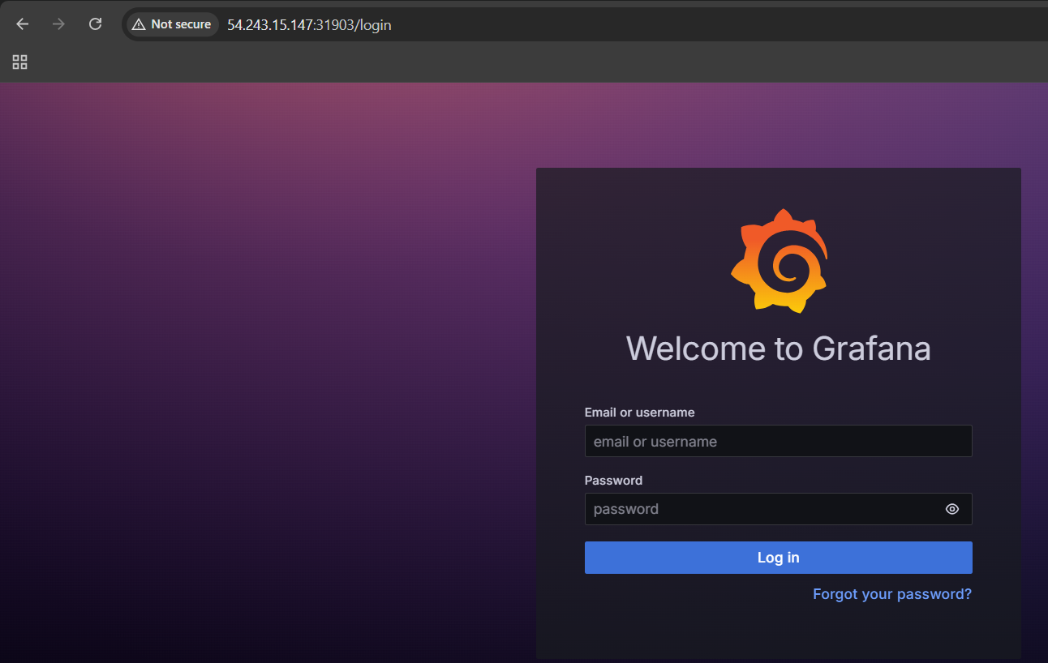

# --- GET GRAFANA PASSWORD ---
kubectl get secret --namespace monitoring prometheus-grafana -o jsonpath="{.data.admin-password}" | base64 --decode; echo

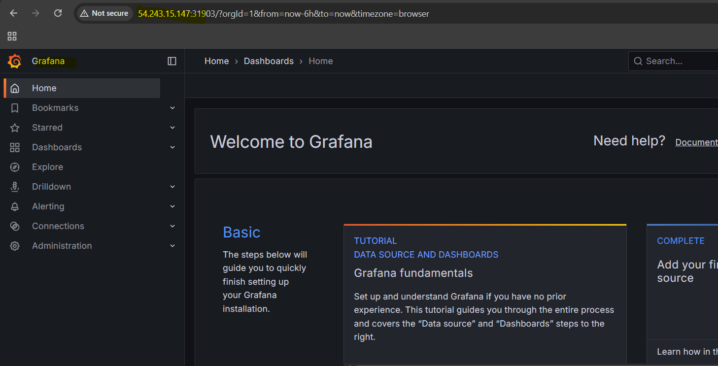
10.Use Prometheus to monitor K8s Metrics like number of Pods & Nodes

# Total number of Pods in the "monitoring" namespace
count(kube_pod_info{namespace="monitoring"})

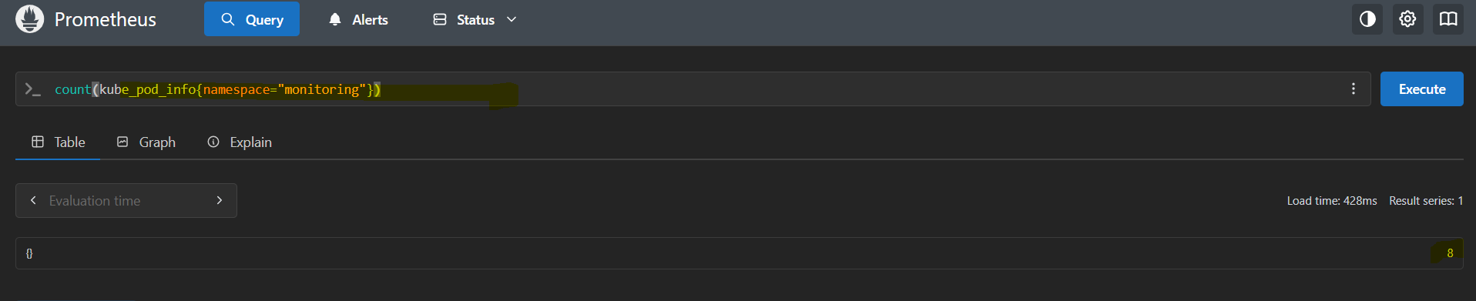

# Total number of Pods in all namespaces
count(kube_pod_info)

# Total number of Nodes in the cluster
count(kube_node_info)

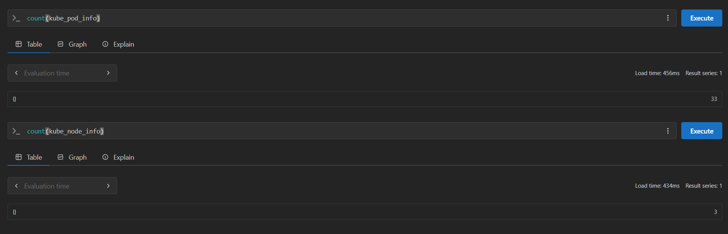

# Total number of Ready Nodes in the cluster
count(kube_node_status_condition{condition="Ready",status="true"})

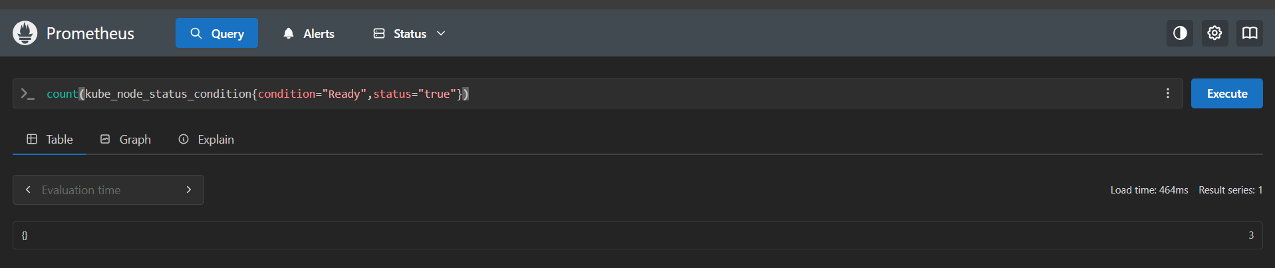

The kube-state-metrics pod is basically a "metrics generator" that scrapes the Kubernetes API server for object states (Pods, Nodes, Deployments, etc.) and then exposes those as Prometheus-compatible metrics at /metrics.

11.Build a Grafana Dashboard for Step 10

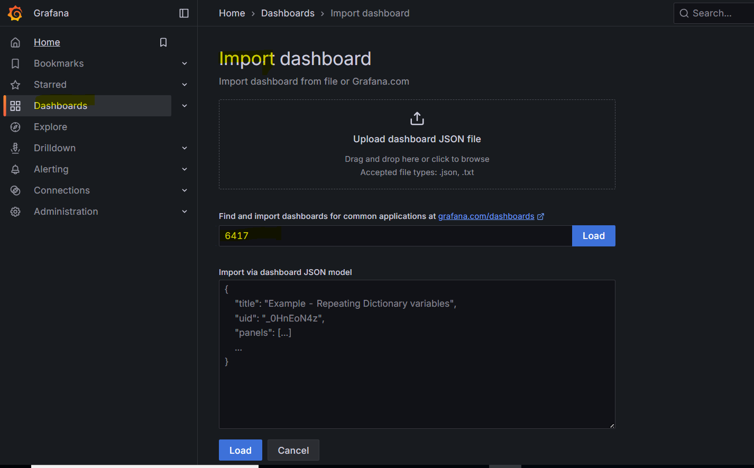
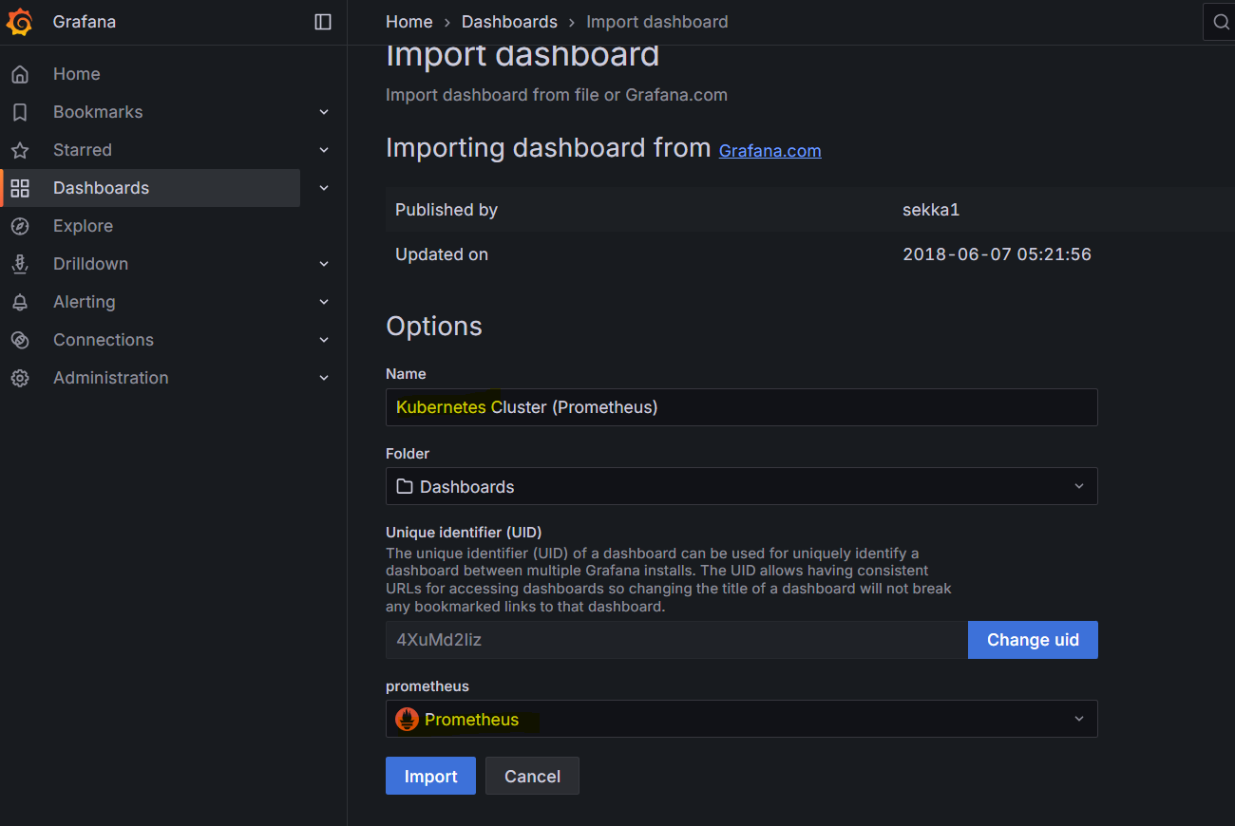
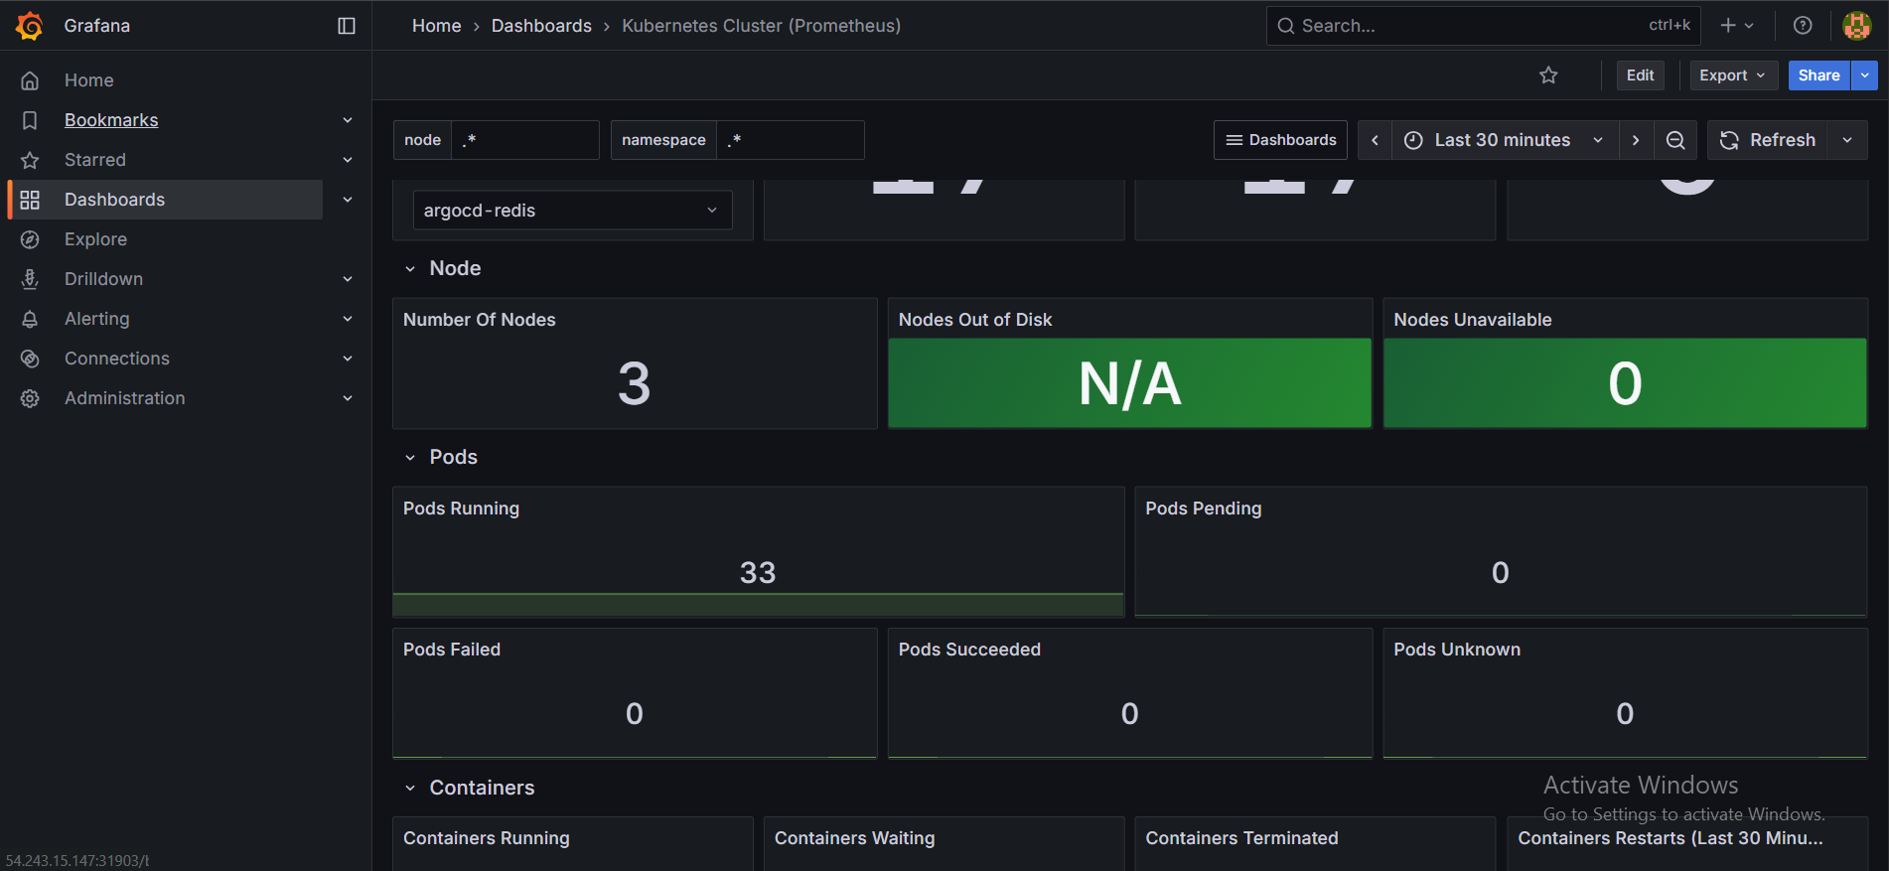

THE-END

